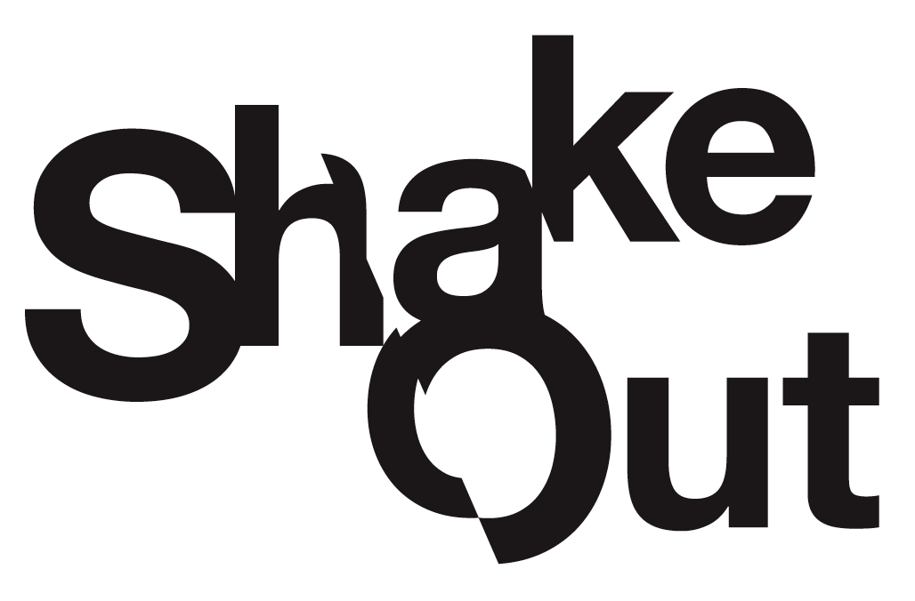

ShakeOut Messaging/Graphics 2015

for Newsletters/Web Pages/Articles

Table of Contents

“Short Version” (Website sidebars, email blasts)................................................................2

“Blurb Version” (Bills, small newsletters, websites)…...................................................... 3

“Newsletter Version” (Newsletters)....................................................................................6

Short Versions: Website sidebars, email blasts, etc.

1

***
Everyone, everywhere should know how to protect themselves during an earthquake. What we do now will determine what our lives will be like afterwards. Register you or your organization in ShakeOut at http://www.ShakeOut.org/register to practice what to do when you feel shaking along with millions!

***
2

Know what to do the moment the ground starts shaking? Drop, Cover, and Hold On! Register you or your organization in ShakeOut to demonstrate your commitment to earthquake safety and inspire others at http://www.ShakeOut.org/register. Take part in the world’s largest earthquake drill!

***
3

Don’t leave it to luck. Be the world’s next great survival story! Register for ShakeOut, the largest earthquake drill, at http://www.ShakeOut.org/register to practice earthquake safety along with millions! Prepare now to survive and recover from the next damaging earthquake.

***
4

The ground starts shaking – it’s an earthquake! What do you do? Drop, Cover, and Hold On! If you’ve never heard this before, visit http://www.ShakeOut.org/register to practice how to be earthquake-safe with millions. The life you save may be your own or others - practice together!

“Blurb” version: Bills, small newsletters, websites, etc.

1
Everyone, everywhere should know how to protect themselves from an earthquake. The International ShakeOut Day of Action on 10/15 at 10:15 a.m. is a day of special events featuring the largest earthquake drill ever, organized to inspire many to get ready for big earthquakes, and to prevent disasters from becoming catastrophes. What we do now, before a big earthquake, will determine what our lives will be like afterwards. The ShakeOut drill will occur in houses, schools, businesses, and public spaces.

Free registration at http://www.ShakeOut.org/register will pledge an individual’s or organization’s participation in this important preparedness event.

***
2
Earthquakes may happen anywhere you work, live, or travel. So everyone, everywhere should know how to protect themselves from an earthquake! Great ShakeOut Earthquake Drills are our chance to practice together how to protect ourselves, and for everyone to become prepared. Prepare now to survive and recover from the next damaging earthquake.

At 10:15 a.m. on 10/15, join millions who will take earthquake-safe actions when seconds count. In order to act quickly, you must practice what to do – ShakeOut is that opportunity. Register at http://www.ShakeOut.org/register to learn more. Invite friends and family to practice, too!

***
3

When the shaking starts and adrenaline pumps, will you know what to do? In an earthquake, you may only have seconds to protect yourself before strong shaking knocks you down, or something falls on you. Practice Drop, Cover, and Hold On at 10:15 a.m. on October 15. Don’t wait until the shaking – practice Drop, Cover, and Hold On with ShakeOut and register with millions at www.ShakeOut.org/register

Invite everyone who matters to you to register and ShakeOut on October 15 at 10:15 a.m. Everyone is welcome to participate - individuals, families, businesses, schools, government agencies and organizations!

Newsletter Version

Are You Ready to ShakeOut?
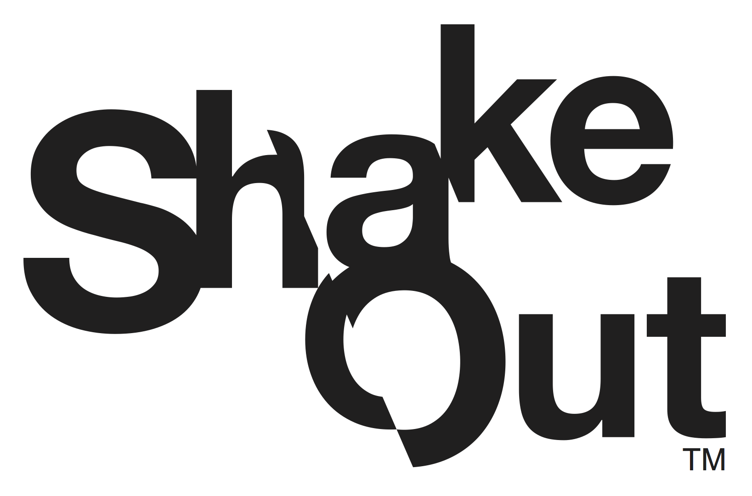
Earthquakes can happen anywhere, anytime, as we all live on big, moving blocks of earth’s crust! What we do now, before a big earthquake, will determine what our lives will be like afterwards. We must act quickly to ensure that disasters do not become catastrophes. Everyone, everywhere should know how to protect themselves from an earthquake!
In 2014, ShakeOut involved over 26.4 million people via a broad-based outreach program, media partnerships, and public advocacy by hundreds of partners. The drill is held each year on the third Thursday of October, and is coordinated globally by the Southern Earthquake Center and regional partners throughout the world. The 2015 International ShakeOut Day of Action earthquake drill will be at 10:15 a.m. on October 15.
A key aspect of the ShakeOut is the integration of comprehensive science-based earthquake research and the lessons learned from decades of social science research about why people get prepared. The result is a “teachable moment” on par with having an actual earthquake (often followed by increased interest in getting ready for earthquakes). ShakeOut creates the sense of urgency that is needed for people, organizations, and communities to get prepared, to practice what to do to be safe, and to learn what plans need to be improved.
Not just any drill will accomplish this; it needs to be big. It must inspire communities to come together. It must involve children at school and parents at work, prompting conversations at home. It must allow every organization, city, etc., to make it their own event.
The 2015 ShakeOut drill will be the largest preparedness event in world history. To participate, go to www.ShakeOut.org/register and pledge your family, school, business, or organization’s participation in the drill. Registered participants will receive information on how to plan their drill and how to create a dialogue with others about earthquake preparedness. All organizers ask is that participants register (so they can be counted and receive communications), and at the minimum practice "drop, cover, and hold on" at the specified time. It is only a five-minute commitment for something that can save your life. It all begins with registering, which is free and open to everyone.
For more information, visit www.ShakeOut.org.

