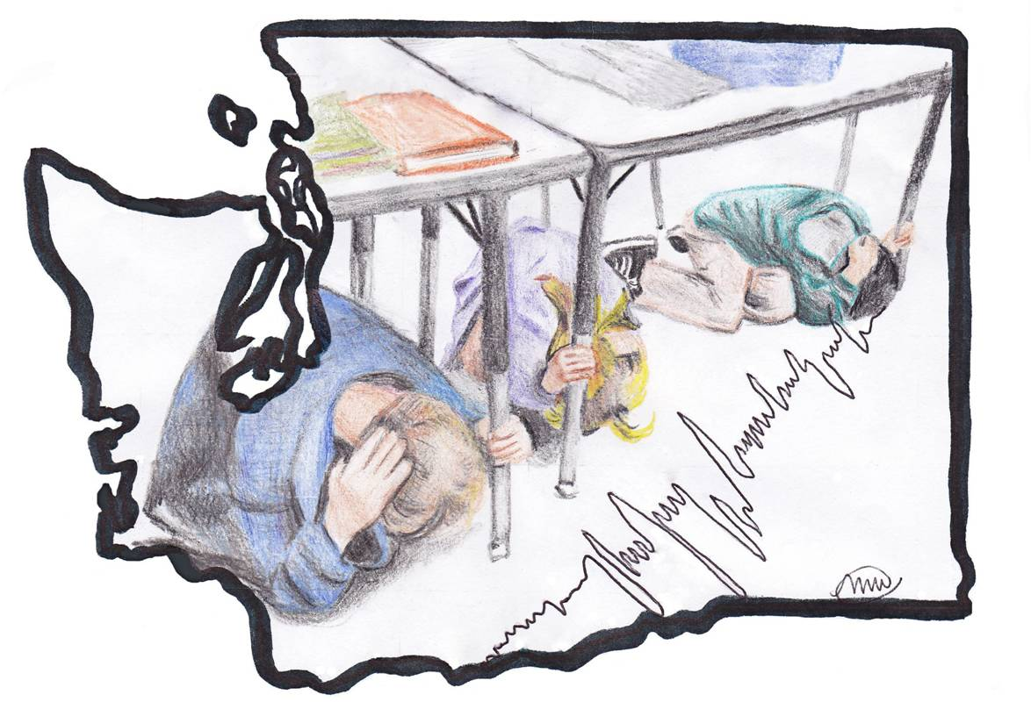
Outsmart the Quake!

Lesson Three: Home Safety

Grade Level: 6-8
WA State Science Learning Standards: 6-8 APPD, 6-8 APPE, 6-8 ES2F
Estimated Time: 45-60 minutes
Materials Needed:
- Dry erase markers
- Pen and paper for each student
- Lesson 3 - Home Safety PowerPoint

General Overview and Purpose
Aside from school, children spend a majority of their time at home; much of this time is spent in their bedroom. On average, a middle school student spends a third or more of their day sleeping. An earthquake can happen at any time throughout the day therefore it is important for the students to identify the dangers an earthquake could cause in their bedroom and throughout their home. Students will accomplish this by learning how to analyze their surroundings to identify dangers and apply easy, low-resource safety strategies to lessen these dangers.

Objective
- Students will recognize earthquake dangers in their homes.
- Students will learn how to complete a rapid visual screening for earthquake dangers.
- Students will develop strategies to lessen earthquake dangers in their home.

Preliminary Brainstorming
Ask the students to reflect on the previous lesson on personal safety. Have the students brainstorm the potential earthquake dangers they learned about in the previous lesson, such as overhead lights, windows, bookshelves, etc.

Step | Estimated time | Description
1 | 15 minutes | Rapid visual screening:  Show the students the pictures located in the Lesson 3 - Home Safety PowerPoint. Have the students raise their hands and point out any dangers they see in the pictures. On the whiteboard or overhead projector, compile a list of the dangers identified (see Appendix C for examples). Point out dangers the students missed if applicable.
2 | 10 minutes | Build a discussion around the dangers the students identified by asking the students why they identified specific items. Instruct the students to rank the dangers from the most concerning to the least concerning. Next, have the students come up with ways to lessen the dangers they identified (see Appendix C). Write down student’s strategies to avoid potential dangers on the whiteboard or overhead projector. Tell the students they just completed a rapid visual screening.
3 | 2 minutes | Now have the students think about their own bedrooms. Give them two minutes to write down as many earthquake dangers they can from their bedroom.
4 | 10 minutes | Divide the students into small groups and prompt the students to discuss the potential dangers in their bedrooms and ways to lessen these dangers.
5 | 10 minutes | Ask the students to share the methods they proposed to make their bedrooms safer. Emphasize the importance of having their bed away from windows, overhead lights, bookshelves, and any other heavy piece of furniture that may fall over.3
6 | 5 minutes | Provide the students with tips to be prepared for an earthquake. This includes keeping shoes and a flashlight beside their bed to avoid stepping on broken glass.

APPENDIX C
Note: Recommended dialogue is in italics

Vocabulary:
Rapid Visual Screening: Quickly scanning a room for potential earthquake dangers.

Preliminary Brainstorming
Get the conversation started by asking the students about the dangers they identified in their classroom in the previous lesson on school safety.

Suggested questions:
- What are some of the dangers we identified around the classroom in our second lesson?
- If an earthquake just occurred, can you imagine what the classroom would look like?

Step 1
In this step students will analyze pictures of several rooms around a typical home and identify potential earthquake dangers. The Lesson 3 - Home Safety PowerPoint contains the pictures for this exercise. Ask the students what dangers they see in each picture. If the students are slow to respond, remind them of dangers they identified around the classroom. See the table below for examples and discussion ideas. Make a list of the dangers the students identify in each room on the whiteboard or overhead projector.

Step 2
Build a discussion around the list of dangers the students identified. Ask the students why they picked specific items. Are there any similarities between the dangers in each room? Similarities may include light fixtures, picture frames above a bed, or heavy objects on a high shelf (see table for more examples). Ask the students to rank the dangers from the most concerning to the least concerning. Then ask the students why certain dangers are more critical than others. Starting with the most concerning danger, ask the students to brainstorm strategies to eliminate each of the dangers listed. If the discussion is slow use the examples in the table below. Write down the recommended safety strategies next to the dangers on the whiteboard or overhead projector.

Step 3
Have the students think about earthquake dangers in their own bedrooms.

Now picture your own bedroom. Write down as many earthquake dangers as you can in two minutes.

Step 4
After two minutes have gone by, break the students into groups of two or three. Instruct the students to discuss the list of dangers they wrote down, and discuss what can be done to reduce or eliminate the danger.

Step 5
Return to a class discussion. Ask the students what earthquake dangers they came up with in their bedroom. For each danger a student mentions, ask them what can be done to reduce or eliminate this danger. Use the table below for examples.

Step 6 & Debriefing
Wrap up the lesson by summarizing the safety strategies, such as moving heavy objects from above a bed or applying earthquake putty to items on shelves. Use the table below for more examples. During an earthquake, the best way to protect yourself is to drop, cover, and hold on. However, taking preventative actions prior to an earthquake can eliminate dangers altogether. Explain to the students that they can complete rapid visual screenings for every room in their home. Also strongly suggest that the students keep a pair of shoes and a flashlight by their bed.

Although it may not seem like it, you spend around a third of your day in bed. An earthquake may start while you are in bed. An earthquake can happen at any time so it is important to always be ready. The most common injury from an earthquake is cuts from broken glass. Why might that be?

When earthquakes happen while people are in bed, they often get out of bed with bare feet and step on broken glass as they walk around. Often, after earthquakes, the electrical system is damaged and the lights will not turn on.

An easy way to be more prepared for earthquakes that may happen at night is to keep an old pair of shoes and a flashlight by your bed. Tying your shoes and a flashlight to a leg of your bed, or placing them in a bag and tying that to a leg of your bed, will make sure the shoes do not slide across the room in the shaking. After the shaking stops, you will be able to reach down, untie the shoes, put them on and use the flashlight to more safely find your parents or evacuate your house.

Possible dangers around your home ⁸ ⁹ ¹¹ ¹² ¹⁵ | Safety Strategies ⁸ ⁹ ¹¹ ¹² ¹⁵
Threat: Hanging lights over bed or sitting areas  Justification: Hanging light fixtures may fall during an earthquake. This could cause injuries if you are in bed during an earthquake. | Move your bed or couch/seat from underneath light fixtures.  Replace hanging light with floor lamp or other light fixture. Secure hanging lights with wire to the ceiling.
Threat: Tall bookshelves near bed, sitting areas, or near exits  Justification: Unsecured bookshelves may fall over during an earthquake and injure people or block exits. | Move unsecured bookshelves away from your bed or sitting areas or near exits.  Secure tall bookshelves to the wall.
Threat: Windows near bed  Justification: Windows may shatter during an earthquake. Cuts from glass are a common injury in an earthquake. | Move you bed away from windows.  If your bed cannot be moved away from a window, heavy curtains can stop shattering glass from falling onto beds.
Threat: Heavy or breakable items on shelves  Justification: Heavy or breakable items may fall from shelves during an earthquake. Getting hit by a heavy/breakable object could cause injuries during an earthquake. Broken glass may cause injuries during or after an earthquake. | Move heavy or breakable objects off of high shelves to lower.  Secure items with adhesives, such as earthquake putty/sticky putty.  Place heavy/breakable items and items with a low center of gravity on a non-skid pad.  Place items in a cabinet with latches.
Threat: Heavy painting or picture above bed or sitting areas  Justification: Heavy paintings/pictures may fall during an earthquake. A falling painting/picture could cause injuries during an earthquake. | Move paintings and pictures from above your bed and sitting areas.  Use closed hooks/security hanger to hang pictures.  Attach the picture frame wire to the nail using a twist tie  Replace with soft art, such as a tapestry.
Threat: Mirror above bed or sitting areas  Justification: Mirrors may fall or shatter during an earthquake. A falling mirror could cause injuries during an earthquake. A shattered mirror could cause injuries before or after an earthquake. | Move mirrors away from your bed and sitting areas

Supplementary Homework Assignment
In the supplementary homework assignment students will complete a rapid visual screening of their bedroom. Instruct them to record any earthquake dangers they found in their room, the safety strategy they used to eliminate the danger, and the date they completed the safety strategy. This assignment can also be done for additional rooms in their homes.

Rapid Visual Screening Worksheet
Room:

Hazard description | Safety Strategy | Date of completion
Example:  A heavy framed picture is located above my bed. | I moved the picture to a different location away from my bed. | 5/20/2012

Outsmart the Quake! lesson plans are intended to support 6th-8th grade student learning about disaster preparedness in conjunction with the Washington State ShakeOut drill. The lessons were developed in 2012 by Western Washington University students Nora Jagielo, Pamela Griswold, Spencer Andrich, Pat Chappelle and Ryan Bainbridge as part of the Disaster Risk Reduction Planning Studio. If you have questions, comments or concerns, please contact Dr. Rebekah Green at Western Washington University’s Resilience Institute. Rebekah.green@wwu.edu.
National Sleep Foundation. (2011). Children and sleep. Retrieved from http://www.sleepfoundation.org/article/sleep-topics/children-and-sleep
FEMA. Federal Emergency Management Agency, (1995). Seismic sleuths . Retrieved from website: http://www.fema.gov/library/file;jsessionid=7DDAC57A5DDF8A2E61F200AD4E31951C.WorkerLibrary?type=publishedFile&file=fema253.pdf&fileid=eca97750-1ed5-11de-9100-001185636a87 (295)
Southern California Earthquake Center. (n.d.). Identify potential hazards in your home and begin to fix them. Retrieved from http://www.earthquakecountry.info/roots/step1.html
Washington Military Department, Emergency Management Division. (2011). Getting ready: Home preparedness. Retrieved from website: http://www.emd.wa.gov/preparedness/prep_infocus_gettingready.shtml
Petal, M. (2009). Urban disaster mitigation and preparedness: The 1999 Kocaeli earthquake. (Master's thesis). (p. 244)
Southern California Earthquake Center. (n.d.). Identify potential hazards in your home and begin to fix them. Retrieved from http://www.earthquakecountry.info/roots/step1.html
http://www.ready.gov/earthquakes
Scientists of the U.S. Geological Survey. (1994). Earthquake of 17 January 1994. Science, 226(5184), 389-397. Retrieved from http://www.jstor.org/stable/pdfplus/2885318.pdf (p. 395)
Totally unprepared. (n.d.). Retrieved from http://www.totallyunprepared.com/get-ready-quick/
U.S. Department of the Interior, U.S. Geological Survey. (2009). Earthquake preparedness. Retrieved from website: http://earthquake.usgs.gov/learn/faq/?categoryID=14&faqID=83
National Sleep Foundation. (2011). Children and sleep. Retrieved from http://www.sleepfoundation.org/article/sleep-topics/children-and-sleep
Iglowstein, I., Jenni, O., Molinari, L., & Largo, H. (2003). Sleep duration from infancy to adolescence: Reference values and generational trends. Pediatrics, 111(2), 302-7. Retrieved from http://www.ncbi.nlm.nih.gov/pubmed/12563055
Washington Military Department, Emergency Management Division. (2011). Getting ready: Home preparedness. Retrieved from website: http://www.emd.wa.gov/preparedness/prep_infocus_gettingready.shtml

