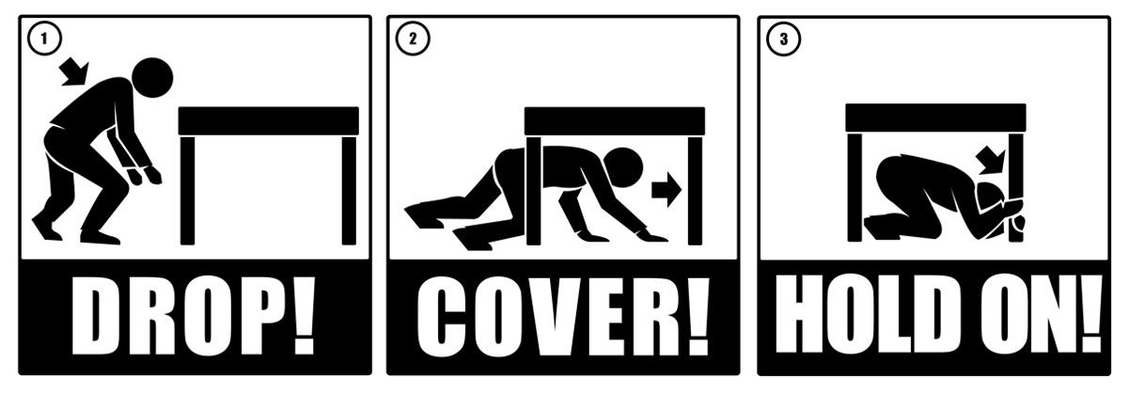

Preparation: Monday, October 14, 2013
- Prior to the exercise, make sure you have discussed with your staff the DROP, COVER, and HOLD On safety tips, their duties and responsibilities during an emergency, the code activation, the location of the Hospital Command Center and the location of your department plan.
- Instruct the staff to remove any clutter and miscellaneous items from under tables, desks, and counters and place them in a more appropriate storage area. Share with the need to keep their work areas clutter free.
Exercise Day: Initiating the Exercise – Thursday, October 17, 2013
- Exercise activations are scheduled for (Enter time, such as 0200 a.m., 1017 a.m., 1300 p.m., and 1800 p.m.)
- Listen for the announcement of a Code Triage Internal. At that time you are to instruct your staff to DROP, COVER and HOLD ON.
- Notify patients and visitors that (Enter facility name) is conducting an exercise.
- Observe our staff’s participation in the exercise and address any issues they may have at that time
- Distribute the sign-in sheets and the evaluations to staff.
- Collect all sign-in sheets and the evaluations. Send the sheets to (Insert name and location).
- Bring your completed Department Status Report to the Hospital Command Center (no later than 15 minutes after the initiation of the exercise).
Exercise Day: Command Center(s) – Thursday October 17, 2013
- The Hospital Command Center(s) will be activated at the designated exercise times.
- Hospital Command Center(s) will contact (Insert government point of contact) to announce their activation.
- Incident Commander will assign Command and General Staff positions.
- The Hospital Command Center will collect all drill material from managers e.g. department sign-in sheets, evaluations, and Department Status reports.
- The Incident Commander will instruct that the “All Clear” message be transmitted.
- All documents from the Command Center(s) must be sent to (Insert name and location).
Exercise Day: Communications – Thursday, October 17, 2013
- IT/Communications will send (at the designated exercise times) the following message using all hospital communication devices: “This is a drill – (Insert facility name) has activated a Code Triage Internal – This is a drill.”

