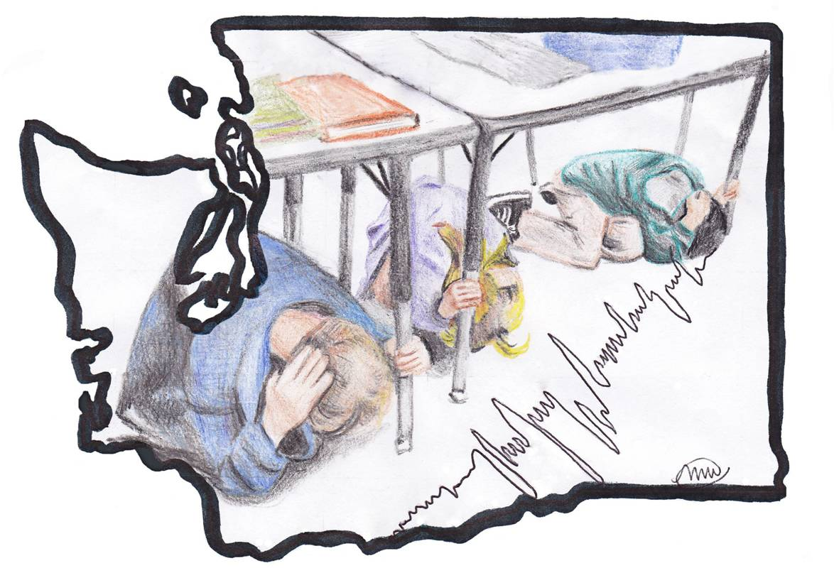
Outsmart the Quake!

Lesson One: Disasters are Preventable

Grade Level: 6-8
Estimated Time: 60 - 80 minutes
Washington State Science Learning Standards: 6-8 APPD, 6-8 APPE, 6-8 ES2F
Materials Needed
- Notebook paper
- Felt tip markers
- Tape
- Disaster are Preventable PowerPoint

General Overview and Purpose
This lesson plan aims to educate students on the difference between a hazard and a disaster. Through facilitated group discussion, the goal is to demonstrate that hazards like earthquakes do not have to turn into disasters. Disasters can be avoided through proper preparation beforehand and students can make a substantial difference. Showing how students can make a difference will be accomplished by sharing stories of other students who have saved lives and assisted communities before and during disasters. As a result, the students will build their confidence and more readily be assets to their communities during hazard events.

Objective
Students will be able to define the terms hazard and disaster.

Step | Time | Description
1 | 15 minutes | Mini presentation on Hazards and Disasters.  Use the information in the Lesson 1 – Disasters are Preventable PowerPoint to introducer the definitions of a hazard and a disaster.
2 | 15 minutes | Hazard versus Disasters Activity  Split the class into two groups. Ask half of the class to give an example of a “hazard.” Ask the other half of the class to give an example of a “disaster.” Allow 10 minutes for students to think and answer, then collect all of the answers.
3 | 10 minutes | Based on the definitions given in the PowerPoint presentation, discuss the similarities and differences between disasters and hazards. See Appendix A for examples of similarities and differences.
4 | 25 minutes | Create a heading for “hazard” and “disaster” on the whiteboard or a large piece of paper. Using the papers collected in Step 2, select student’s responses at random. As a class, identify if the answer describes a hazard or a disaster using the knowledge learned during the mini lecture. As each card is identified, tape it under the appropriate heading.  If the answer describes a disaster, brainstorm different techniques that could have been used beforehand in order to avoid the disaster. See Appendix A for examples.
6 | 5  minutes (optional) | Share the story of Tilly Smith, a young girl who saved many people from a tsunami in Thailand. (Appendix A)

APPENDIX A
NOTE: Suggested dialog is in italics.

Vocabulary:
Hazard: A human made or natural danger that can threaten a group of people, their belongings, and their environment, if they do not take precautions. Examples of hazards in WA: earthquakes, landslides, flooding, oil spill.

Disaster: A disaster is when a hazard causes such great losses and damage that the affected communities do not have the resources to recover without outside assistance.

Tsunami: A tsunami (pronounced soo-nah-mee) is a series of very long waves that occur over a long period of time. The word ‘tsunami’ is a Japanese word that means ‘harbor wave.’

Pre-Lesson Discussion

“On October 18, 2012 at 10:18am, thousands of people in Washington (including businesses, schools, homeowners, etc.) will be “Shaking it Out” by participating in the Great Washington ShakeOut event, a state-wide earthquake preparedness exercise. This is the largest earthquake preparedness exercise Washington has ever participated in, offering an exciting opportunity to learn and prepare for when an earthquake happens. This event has been happening for years in California. Last year (2011), 5.8 million students participated in the event.”

Step 1
Mini lecture on hazard and disaster using the Disasters are Preventable PowerPoint provided. Teacher notes are included.

Step 2
Ask half the class to define what a “hazard” is on a piece of paper. Ask the other half of the class to write down what makes for a “disaster.” Distinguishing between a hazard and a disaster is relatively confusing for some students (and adults!) initially. However, making a distinction helps students and adults understand what is uncontrollable (a hazard) and what is controllable (whether or not a hazard results in a community-wide disaster). Students will likely be able to name hazards easily; they may have more difficulty naming disastrous outcomes of these hazards. If your students charged with naming disasters are confused, get them thinking by asking them about the “disastrous” or “undesirable” impacts of a hazard and what type of things they would see. The student’s responses during this exercise will be important later in the lesson when, as a class, students decide whether or not their responses describe a hazard or a disaster. Likely, some answers will change from one to another. For example, if a student answers “earthquake” as a disaster, it would move to hazard.

Step 3
Review the definition of a hazard and a disaster.

A hazard is a human made or natural danger that can threaten a group of people, their belongings, and their environment, if they do not take precautions. Examples of hazards in WA: earthquakes, landslides, flooding, oil spill.

A disaster is a hazard that causes such great losses and damage that the affected communities do not have the resources to recover without outside assistance.

HAZARD | DISASTER
Earthquake | - East Japan Earthquake (2011)  - Haiti Earthquake (2010)
Landslide | - Gansu Mudslide (2010)
Flood | - Queensland flood (2010-2011)  - Missouri Floods (2011)
Oil spill | - Deepwater Horizon Oil Spill (2010)

As a class, compare and contrast the differences and similarities between hazards and disasters. Some possible answers include:

Similarities | Differences
- Both may be unexpected  - Both are relatively rare occurrences  - Both frighten people  - Both can be large or small | - Many hazards can’t be stopped; planning and preparing for the hazard can stop many disasters.  - A hazard may happen quickly. A disaster may unfold over a long period of time.  - A hazard can happen anywhere. A disaster can only happen where we care about the impacts.  - Hazards are studied by physical scientists (meteorologists, geologists, volcanologists, etc.); disasters are studied by social scientists and others (economists, historians, sociologists, policy makers etc.)

Step 4
Create a heading for “hazard” and “disaster” on the whiteboard or a large piece of paper. Using the papers collected in Step 2, select student’s responses at random. As a class, identify if the answer describes a hazard or a disaster using the knowledge learned during the mini lecture. As each card is identified, tape it under the appropriate heading.

If the answer describes a disaster, brainstorm different techniques that could have been used beforehand in order to avoid the disaster.

Step 5
If the answer describes a disaster, brainstorm different techniques that could have been used beforehand in order to avoid the disaster.

Examples of mitigation techniques that can help prevent disasters:
Hazard | Disaster | Technique | Justification | Source
When a flood does not affect many people, it is a hazard. For example, a flood that occurs in a marsh or an undeveloped flood plain. | When flooding affects a lot of people, it can become a disaster. Some impacts in a flood disaster are flooded houses and inaccessible roads. This isolates people from getting resources (like food and clean water) and also isolates people from responders who cannot reach them. | Build houses and shops outside of flood plains; raise houses on stilts when they are inside a flood plain. | Flooding hazards only evolve into disasters when people live in the flood prone area. If people were to move out of floodplains, it would not be a disaster. | U.S. Federal Emergency Management Agency, 2005.
Hazards, like an earthquake, have the potential to disrupt communications. | In a disaster, communications (like cell phone service) are almost always disrupted. How long they are disrupted varies each event. It can be difficult to reach family and friends to know that they are safe. | Prepare a disaster plan with your family to establish meeting places, out of area contacts, and other critical information useful when communications were down. | Making a plan beforehand is important because hazards can strike suddenly at any time. Preparing beforehand will allow you and your family to all is on the same page if and when something does happen. Creating a plan can save lives. | American Red Cross, 2012.
Earthquakes can cause the ground to shake intensely. On a flat, open grassland or forest the shaking may only frighten some animals but cause little damage. | When earthquakes happen near cities, the shaking can damage buildings. Older and weaker buildings may be heavily damaged or collapse, costing a lot of time and money to build back. Shaking may damage cell phone towers, water lines, and bridges, making it harder for a community to function. | Make buildings, towers, bridges, and pipes stronger | Reinforced infrastructure is more able to withstand the pressures and stresses of an earthquake’s shaking. | U.S. Federal Emergency Management Agency, 2005.
 | During an earthquake, hazards like glass, falling bricks, picture frames, etc. can all cause injury to an individual. | If an individual knows what to do before a disaster happens they are more likely to take protective action. Educating the public about what to do (i.e Drop, Cover, and Hold On) | Neighbors, teachers, and students will be the first to respond to people in need of assistance during a disaster. | Petal, M.; 2009.  and  Ripley, A.; 2009.

Step 6 – Optional
Share the story of Tilly Smith. Briefly introduce what a tsunami is and how it is created if the students have not learned about this hazard previously.

What is a tsunami?

“A tsunami is a series of waves. These waves travel across the ocean and crash into the shore. These waves travel faster than a person can run, and can be very dangerous. In deep water, a tsunami does not cause damage. Large ships may not even feel them. But when the tsunami gets close to the shore the waves grow. In shallow water the waves can get very big – as high as 100 feet.”

How is a tsunami formed?

Here is a good video provided by the National Oceanic and Atmosphere Administration (NOAA): http://www.youtube.com/watch?feature=player_embedded&v=tUN_UTY0GNo

How Tilly Smith saved lives

In 2004, a ten-year-old British girl named Tilly Smith was able to save hundreds of lives because she recognized the signs of a tsunami and warned people to evacuate by moving to higher ground. At the time, she was on vacation with her family in Thailand and began to observe the seawater receding. When she first started urging people to evacuate, they did not listen. But then, she urged her family to help her convince the beach goers that evacuation was crucial. Evacuation to higher ground before a tsunami occurs is effective because it moves you out of the area of danger.

Tilly’s warning saved many peoples lives and increased awareness about the importance of proper preparedness. Tilly’s story is an example of how knowing what to do before hand may save your own life, and the lives of those around you.

Optional video of her story (five minutes): http://www.preventionweb.net/english/multimedia/v.php?id=970&hid=71

Further resources showing how tsunami waves work:
- http://science.howstuffworks.com/nature/natural-disasters/tsunami3.htm
- http://www.pbs.org/wnet/savageearth/animations/tsunami/index.html

Optional Homework Assignment

Below, there is a homework assignment titled “Hazard versus Disaster” to reinforce what the students learned in this lesson.

Name: ________________________________________
Date: _________________________________________
Hazard versus Disaster
For each scenario below, circle whether you think it is a hazard or a disaster and why you think so. If it is a disaster, list some ideas of what the community could do beforehand to prevent the damage from happening.

- A flood wipes out an unpopulated valley deep in the mountains. The landscape is covered with two feet of water.
  - Hazard
  - Disaster
________________________________________________________________________________________________________________________________________________

- A large earthquake near Seattle causes extensive damage. Many people that were not properly prepared are injured or stranded without basic needs like food, water and electricity. The Federal Emergency Management Agency, Red Cross, and other outside organizations provide assistance.
  - Hazard
  - Disaster
________________________________________________________________________________________________________________________________________________

- A severe winter storm causes a power outage for one week, leaving thousands of people without heat, food, and water.
  - Hazard
  - Disaster
________________________________________________________________________________________________________________________________________________

- Heavy rains cause a huge landslide in the middle of Olympic National Park. A few hikers and campers witness the event, but no one is hurt.
  - Hazard
  - Disaster
________________________________________________________________________________________________________________________________________________

Outsmart the Quake! lesson plans are intended to support 6th-8th grade student learning about disaster preparedness in conjunction with the Washington State ShakeOut drill. The lessons were developed in 2012 by Western Washington University students Nora Jagielo, Pamela Griswold, Spencer Andrich, Pat Chappelle and Ryan Bainbridge as part of the Disaster Risk Reduction Planning Studio. If you have questions, comments or concerns, please contact Dr. Rebekah Green at Western Washington University’s Resilience Institute. Rebekah.green@wwu.edu.
UNISDR & UNICEF, (2004). Let’s learn to prevent disasters! Fun ways for kids to join in risk reduction. Retrieved from website: a.http://www.unisdr.org/2004/campaign/booklet-eng/Booklet-english.pdf
Vanaspongse, C., Ratanachena, S., Rattanapan, J., Chuthong, S., & Intraraksa, R. (2007). Training manual child-led disaster risk reduction in schools and communities. Save the Children, Retrieved from http://seap.savethechildren.se/Global/scs/SEAP/publication/publication pdf/Disaster/DRR training manual _eng.pdf
Washington military department emergency management division: Kidz. (2011). Retrieved from http://www.emd.wa.gov/kidz/kidz_secondary.html?content=tsunami1
Owen, J. (2005, January 18). Tsunami family saved by schoolgirl's geography lesson. National Geographic News, Retrieved from http://news.nationalgeographic.com/news/2005/01/0118_050118_tsunami_geography_lesson.html
Ripley, A. (2009, January 26). [Web log message]. Retrieved from http://www.amandaripley.com/blog/tilly_smith_and_the_tsunami/

